

**European Network for Health Technology Assessment**

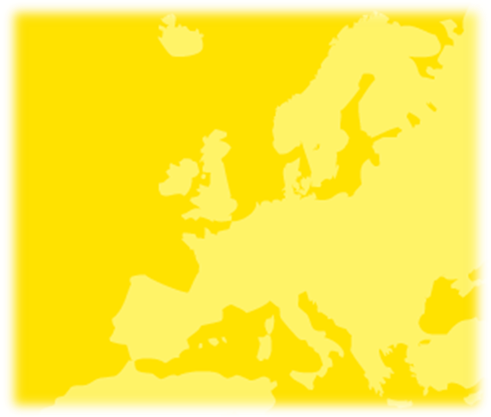

**EUnetHTA JA2**

**WP7 DELIVERABLE**

**Evidence submission**

**templates to support**

**production of core HTA**

**information and rapid**

**assessments:**

**Pharmaceuticals**

**evidence submission**

**template short version**



The EUnetHTA JA 2 (2012-2015) has received funding from the European Union, in the framework of the Health Programme



Joint Action on HTA 2012-2015

**Evidence submission templates to support production of core HTA information and rapid assessments: Pharmaceuticals evidence submission template short version**

Date: October 2015

Was developed by Work Package Work Package 7: Methodology development and evidence generation: guidelines and pilot production

WP 7 Lead Partner: Haute Autorité de Santé (HAS)

WP Subgroup Coordinator: National Institute for Health and Care Excellence (NICE)



**Disclaimer:** EUnetHTA Joint Action 2 is supported by a grant from the European Commission. The sole responsibility for the content of this document lies with the authors and neither the European Commission nor EUnetHTA are responsible for any use that may be made of the information contained therein.

Notes are available on the EUnetHTA website for agencies to use when adapting the submission template for regional, national or joint processes

EUnetHTA pharmaceuticals evidence submission template

Short version

[Technology name]

[Indication for use]

[Company/Sponsor]

Abbreviations

*For agency completion*

Date of receipt:

Identifier:

*Contact details for administrative purposes*

Name of contact person:

Address of contact:

Telephone number:

Email address:

ATC: anatomical therapeutic chemical

CI: confidence interval

CONSORT: consolidated standards of reporting trials

DSM: Diagnostic and Statistical Manual of Mental Disorders

EPAR: European Public Assessment Report

HTA: health technology assessment

ICD: International Classification of Diseases

PRISMA: preferred reporting items for systematic reviews and meta-analyses

RCT: randomised controlled trial

SD: standard deviation

SPC: summary of product characteristics

STROBE: strengthening the reporting of observational studies in epidemiology

VnR: Nordic Article Number

Contents

Abbreviations 3

1 Description and technical characteristics of the technology 3

1.1 Characteristics of the technology 3

1.2 Regulatory status of the technology 3

2 Health problem and current clinical practice 3

2.1 Overview of the disease or health condition 3

2.2 Target population 3

2.3 Clinical management of the disease or health condition 3

2.4 Comparators in the assessment 3

3 Current use of the technology 3

3.1 Current use of the technology 3

3.2 Reimbursement and assessment status of the technology 3

4 Investments and tools required 3

4.1 Requirements to use the technology 3

4.2 Investments, disinvestments and changes in service organisation 3

5 Clinical effectiveness and safety 3

5.1 Identification and selection of relevant studies 3

5.2 Relevant studies 3

5.3 Main characteristics of studies 3

5.4 Individual study results (clinical outcomes) 3

5.5 Individual study results (safety outcomes) 3

5.6 Conclusions 3

5.7 Strengths and limitations 3

References 3

Example presentation of a search strategy 3

**Using this evidence submission template**

This evidence submission template contains suggestions to companies about what information to include, *highlighted in blue*, which agencies can adapt as necessary. There are also ‘form fields’ that prompt companies for their response, for example *[add details here]*. To insert a response, a company should click once anywhere within the highlighted text and then type in their response. This overwrites the section that was highlighted. To delete a form field, click anywhere within the highlighted text and press DELETE.

1. Description and technical characteristics of the technology

Summary of the characteristics of the technology

*In no more than 6 bullet points describe key statements about the technology and its regulatory status.*

*For example, include statements that describe the key features of the technology and its authorisation status.*

* *key statement*
* *key statement*
* *key statement*
* *key statement*
* *key statement*
* *key statement*

1. Characteristics of the technology
2. In table 1 provide an overview of the technology.

Table 1: Features of the technology

|  |  |
| --- | --- |
| Non-proprietary name |  |
| Proprietary name |  |
| Marketing authorisation holder |  |
| Class |  |
| Active substance(s) |  |
| Pharmaceutical formulation(s) |  |
| ATC code |  |
| Mechanism of action |  |

1. In table 2, summarise the information about administration and dosing of the technology.

Table 2: Administration and dosing of the technology

|  |  |
| --- | --- |
| Method of administration |  |
| Doses |  |
| Dosing frequency |  |
| Average length of a course of treatment |  |
| Anticipated average interval between courses of treatments |  |
| Anticipated number of repeat courses of treatments |  |
| Dose adjustments |  |

1. In table 3 provide information about the different packs available.

Table 3: Pack information

|  |  |  |  |  |
| --- | --- | --- | --- | --- |
|  | Pack size | Strength | Form | Pack code  (if available, for example VnR code or barcode) |
| Pack 1 |  |  |  |  |
| *[Insert line for each pack available]* |  |  |  |  |

1. State the context and level of care for the technology (for example, primary healthcare, secondary healthcare, tertiary healthcare, outside health institutions or as part of public health or other).

*[add details here]*

1. State the claimed benefits of the technology, including whether the technology should be considered innovative.

*For example, whether the technology has increased safety, health benefits, compliance and improved features of administration compared with existing technologies.*

*[add details here]*

1. Regulatory status of the technology

*If the technology is not approved include the information that is expected to be approved.*

1. Complete table 4 with the marketing authorisation status of the technology.
2. State any other indications not included in the assessment for which the technology has marketing authorisation.

*[add details here]*

1. State any contraindications or groups for whom the technology is not recommended.

*[add details here]*

1. List the other countries in which the technology has marketing authorisation.

*[add details here]*

Table 4: Regulatory status of the technology

|  |  |  |  |
| --- | --- | --- | --- |
| **Organisation issuing approval** | **Verbatim wording of the (expected) indication(s)** | **(Expected) Date of approval** | **Launched (yes/no).**  **If no include proposed date of launch** |
|  |  |  |  |

1. Health problem and current clinical practice

Summary of issues relating to the health problem and current clinical practice

*In no more than 6 bullet points describe key statements about the health problem and current clinical practice.*

*For example, include statements about the proposed use or target population, unmet needs of treatment and how the technology may address these.*

* *key statement*
* *key statement*
* *key statement*
* *key statement*
* *key statement*
* *key statement*

1. Overview of the disease or health condition
2. Define the disease or health condition in the scope of this assessment.

*If available include a standardised code such as the ICD code or the DSM code (and the version of the code).*

*If relevant describe the main subtypes and/or stages of the disease or health condition.*

*Include any prognostic factors that may affect the course of the disease or health condition.*

*[add details here]*

1. Present an estimate of prevalence and/or incidence for the disease or health condition including recent trends.

*This information may be tabulated or displayed graphically.*

*Include absolute numbers of patients.*

*[add details here]*

1. Describe the symptoms and burden of the disease or health condition for patients.

*Include aspects such as pain, disability, psychosocial issues, or other determinants of morbidity and quality of life from a patient perspective.*

*[add details here]*

1. Describe the aspects of the burden of disease that are targeted by the technology, that is, those that are expected to be reduced by the use of the technology.

*[add details here]*

1. Target population

*The target population may be the population identified in the marketing authorisation or a target group of patients using the technology for which the company wants reimbursement.*

1. Describe the target population and the proposed position of the target population in the patient pathway of care.

*[add details here]*

1. Provide a justification for the proposed positioning of the technology and the definition of the target population.

*[add details here]*

1. Estimate the size of the target population. Include a description of how the size of the target population was obtained and whether it is likely to increase or reduce over time.

*[add details here]*

1. Clinical management of the disease or health condition
2. Describe the clinical pathway of care for different stages and /or subtypes of the disease being considered in the assessment.

*Include a list of relevant guidelines. Table 5 provides a suggested presentation when there are multiple relevant guidelines.*

*Include a diagram of the care pathway. When there are significant variations in care, more than one diagram may be required.*

1. State the technologies currently used in the clinical pathway for which the proposed technology is an alternative, or an additional treatment.

*For non-pharmacological alternatives, the description should include the type of management for example, inpatient or outpatient care, community practice, emergency care and the extent to which the procedure is standardised.*

*There is a separate section for describing the comparators in the assessment – see section 2.4.*

*[add details here]*

1. Describe the pathway of care that incorporates the new technology if the technology were to be adopted for use.

*If a diagram of the existing care pathway has been included, this may be updated to show how the new technology will change the pathway of care. More than one diagram may be required.*

*[add details here]*

Suggested table 5: Relevant guidelines for diagnosis and management

|  |  |  |  |
| --- | --- | --- | --- |
| **Name of society/organisation issuing guidelines** | **Date of issue or last update** | **Country/ies to which guideline applies** | **Summary of recommendations**  **(Level of evidence/grade of recommendation for the indication under assessment)** |
|  |  |  |  |
|  |  |  |  |
|  |  |  |  |
| Include a link to relevant guidelines if publicly available | | | |

1. Comparators in the assessment
2. On the basis of the alternatives presented, identify the technologies to be used as comparator(s) for the assessment.

*Comparators can differ from the technology in their mechanism of action (whether physical, chemical or mechanical).*

*If the comparators are different from the technologies identified as alternatives to the intervention or the technologies to which the intervention will be added, provide a justification for the differences.*

*[add details here]*

1. Current use of the technology

Summary of issues relating to current use of the technology

*In no more than 6 bullet points describe key statements about the current use of the technology.*

*For example, include statements about the availability and reimbursement status of the technology in other countries, the populations in which the technology is currently used (if available).*

* *key statement*
* *key statement*
* *key statement*
* *key statement*
* *key statement*
* *key statement*

1. Current use of the technology

*Complete only if the technology is available in one or more European countries.*

1. Describe the experience of using the technology, for example the health conditions and populations, and the purposes for which the technology is currently used. Include whether the current use of the technology differs from that described in the (expected) authorisation.

*[add details here]*

1. Indicate the scale of current use of the technology, for example the number of people currently being treated with the technology, or the number of settings in which the technology is used.

*[add details here]*

1. Reimbursement and assessment status of the technology

*Complete only if the technology has been launched in a European country.*

1. Complete table 6 with the reimbursement status of the technology in Europe.

Table 6: Overview of the reimbursement status of the technology in European countries

|  |  |  |
| --- | --- | --- |
| **Country and issuing organisation** | **Status of recommendation (positive/negative/ongoing/not assessed)** | **If positive, level of reimbursement\*** |
|  |  |  |
|  |  |  |
|  |  |  |
|  |  |  |
| Include a reference to any publicly available guidance documents  *For example full reimbursement or only partial reimbursement. If partial reimbursement give a percentage of reimbursement. | | |

1. Investments and tools required

Summary of issues relating to the investments and tools required to introduce the technology

*In no more than 6 bullet points describe key statements about the investments and tools required to use the technology.*

*For example, include statements about the equipment and resources required to use the technology and how this differs from the comparators.*

*For example, include statements about any new equipment, premises and personnel that will be required if the technology is introduced, or equipment, premises and personnel that will no longer be required.*

* *key statement*
* *key statement*
* *key statement*
* *key statement*
* *key statement*
* *key statement*

1. Requirements to use the technology
2. If any special conditions are attached to the regulatory authorisation more information should be provided, including reference to the appropriate sections of associated documents (for example, the EPAR and SPC). Include:
   * conditions relating to settings for use, for example inpatient or outpatient, presence of resuscitation facilities
   * restrictions on professionals who can use or may prescribe the technology
   * conditions relating to clinical management, for example patient monitoring, diagnosis, management and concomitant treatments.

*[add details here]*

1. Describe the equipment required to use the technology.

*If all equipment is described in response to question 1, state here that there are no additional requirements.*

*[add details here]*

1. Describe the supplies required to use the technology.

*For example, syringes, needles, pharmaceuticals and contrast agents, fluids, bandages.*

*[add details here]*

1. **Investments, disinvestments and changes in service organisation**

*Complete this section to describe the investments that are needed in order to use the technology (that is, the resources not currently available that will need to be put in place for the technology to be introduced).*

*This section should highlight any differences in requirements for use between the technology and the treatments currently being used.*

1. Describe any changes to current services that are needed to introduce the technology. Include:

* any tests or investigations needed for selecting or monitoring patients that are over and above usual clinical practice
* any equipment, or organisational and technical conditions that will require investment before the technology can be introduced
* any investment in infrastructure
* any programmes and services that will have to be increased due to introduction of the technology (rehabilitation, nursing etc.).

*Consider possible effects on services earlier and later in the care pathway.*

*[add details here]*

1. Describe any tests, investigations, interventions, facilities or technologies that would no longer be needed if the technology is introduced.

*If an existing procedure is replaced: include the replacement rate and the volume of procedures replaced.*

*[add details here]*

1. Clinical effectiveness and safety

Summary of the clinical effectiveness

*In no more than 6 bullet points describe key statements relating to the clinical effectiveness of the technology.*

*For example, include statements about the benefit of the technology compared to alternative technologies currently used.*

* *key statement*
* *key statement*
* *key statement*
* *key statement*
* *key statement*
* *key statement*

Summary of safety

*In no more than 6 bullet points describe key statements relating to the safety of the technology.*

*For example, include statements about the relative safety of the technology compared to alternative technologies currently used.*

* *key statement*
* *key statement*
* *key statement*
* *key statement*
* *key statement*
* *key statement*

1. Identification and selection of relevant studies

*This section should describe how relevant studies were identified:*

* *studies of the technology in the indication under assessment*
* *studies of the comparators (if applicable).*

1. State the databases and trial registries searched and, when relevant, the platforms used to do this.

*[add details here]*

1. State the date the searches were done and any limits (for example date, language) placed on the searches.

*[add details here]*

1. Include as an appendix the search terms and strategies used to interrogate each database or registry.

*For bibliographic databases: Include the complete search strategies (with the names of the interfaces), the years covered by the search, the date of the last search and the number of hits per line.*

*For study registries: Include the search terms, the input interface (for example, basic search or advanced search), and the number of hits retrieved.*

*If a search filter is used (that is, a predefined combination of search terms to filter references with a specific content), provide a reference to the filter used.*

*[add details here]*

1. In table 7, state the inclusion and exclusion criteria used to select studies and justify these.

Table 7: Inclusion and exclusion criteria

|  |  |
| --- | --- |
| Inclusion criteria | Population:  Intervention(s):  Comparator(s):  Outcomes:  Settings (if applicable):  Study design:  Language restrictions:  Other search limits or restrictions applied: |
| Exclusion criteria | Population:  Intervention(s):  Comparator(s):  Outcomes:  Settings (if applicable):  Study design:  Language restrictions:  Other search limits or restrictions applied: |

1. Provide a flow chart showing the number of studies identified and excluded. The [PRISMA statement](http://www.prisma-statement.org/statement.htm) can be used; the PRISMA flow chart is included below, as an example.

PRISMA flow chart

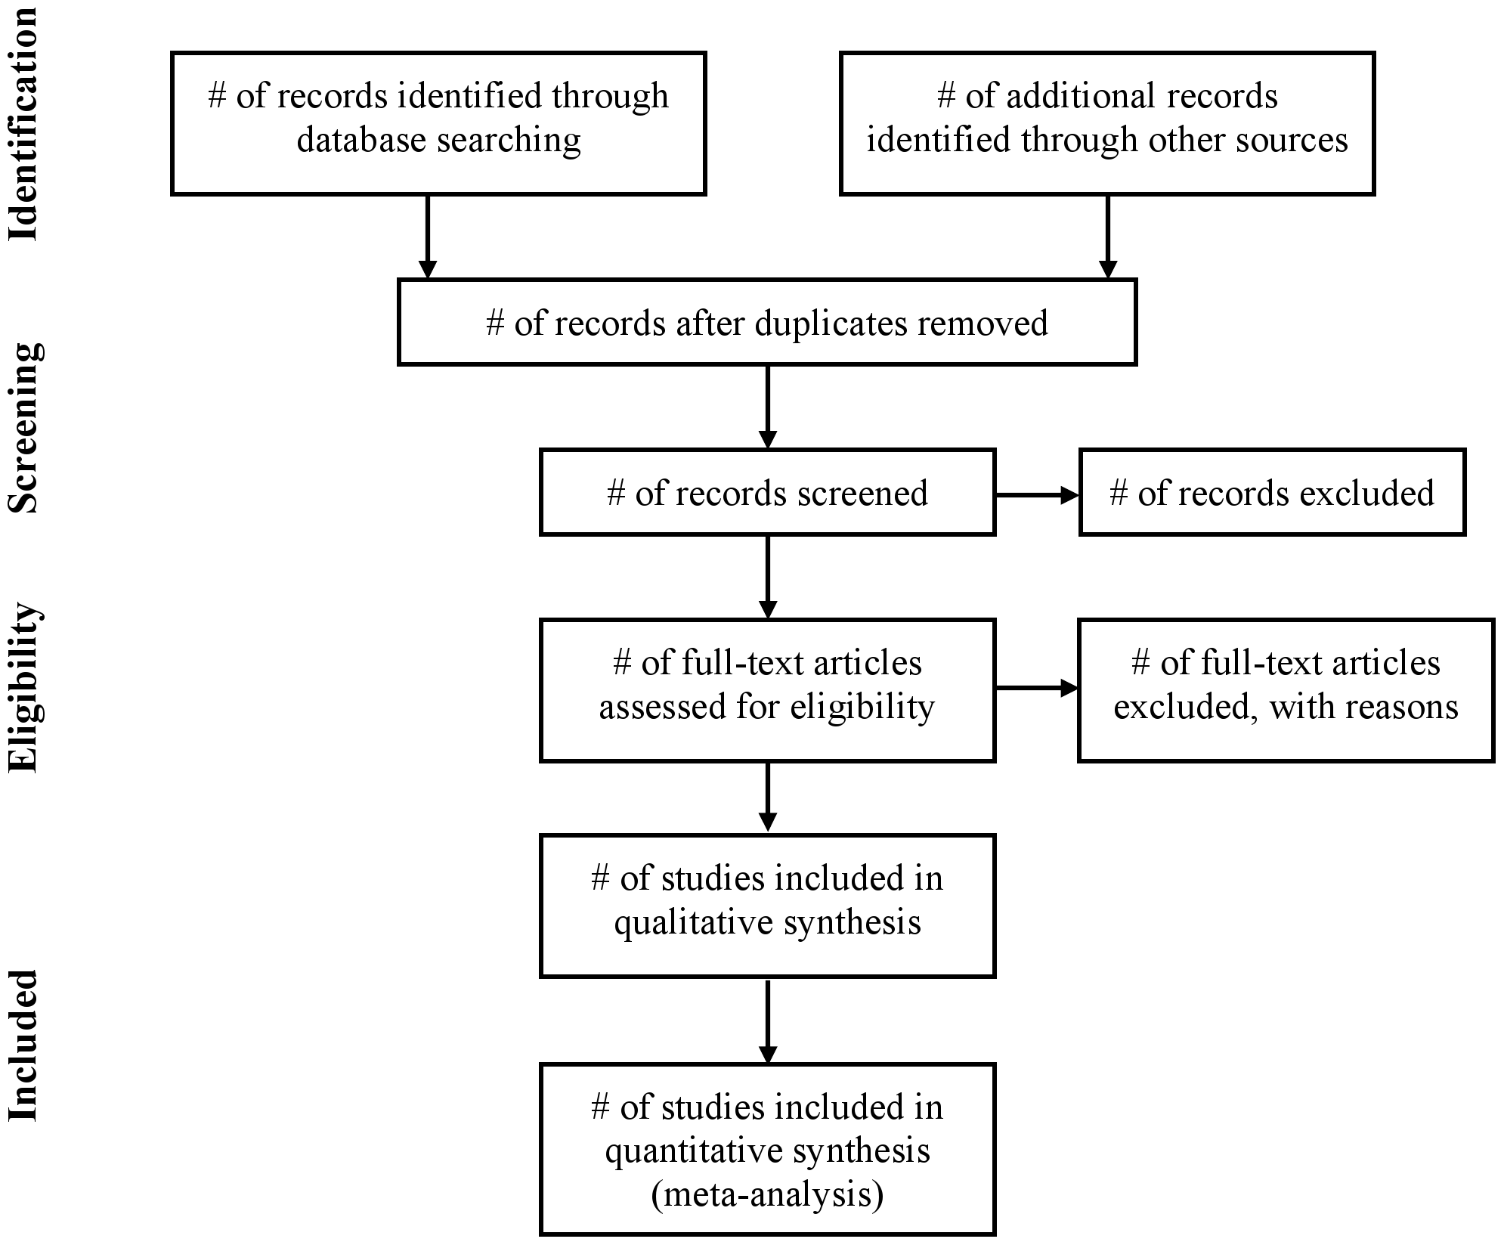

From: Moher D, Liberati A, Tetzlaff J, Altman DG, The PRISMA Group (2009). Preferred Reporting Items for Systematic Reviews and MetaAnalyses: The PRISMA Statement. PLoS Med 6(6): e1000097. doi:10.1371/journal.pmed1000097

1. Relevant studies

*Studies should be ordered by study design (RCT and non-RCT [if applicable]) and status (complete and ongoing).*

*Include all the studies of the technology relevant to the assessment, as well as studies of comparator technologies (if applicable).*

*For assessments where there are a lot of studies, more than one table may be needed; for example dividing the evidence by complete and ongoing studies, randomised and non-randomised evidence or evidence for the technology versus evidence for the comparator(s).*

1. In table 8 provide a list of the relevant studies identified.

Table 8: List of all relevant studies

|  |  |  |
| --- | --- | --- |
| **Study reference/ID** | **Available documentation\*** | **Status**  **(ongoing**/**  **complete)** |
| *Randomised controlled trials* | | |
|  |  |  |
|  |  |  |
|  |  |  |
| *Non-randomised studies* | | |
|  |  |  |
|  |  |  |
|  |  |  |
| *Include references to all linked documents and indicate the expected date of publication for any unpublished clinical studies  **Include expected date of completion | | |

1. Main characteristics of studies

*Further information on the presentation of study information can be found in the* [*CONSORT statement*](http://www.consort-statement.org/checklists/view/32-consort/66-title) *for randomised controlled trials, and* [*STROBE guidelines*](http://www.strobe-statement.org/index.php?id=available-checklists) *for observational studies.*

*Include all the studies of the technology relevant to the assessment, as well as studies of comparator technologies (if applicable).*

*Include ongoing and unpublished studies if these data are available.*

1. In table 9, describe the main characteristics of the studies.
2. For each study provide a flow diagram of the numbers of patients moving through the trial.

*Include: patients evaluated for enrolment, those assigned to a treatment category, patients who received treatment as allocated, patients who completed follow-up and patients included in the main analyses.*

*Tables submitted to the regulatory authorities showing patient flow may be used.*

*[add details here]*

1. For each study provide a comparison of patients (including demographic, clinical and social information [if applicable]) in treatment arms at baseline.

*Tables submitted to the regulatory authorities showing patients’ baseline demographic characteristics may be used if available.*

*[add details here]*

Table 9: Characteristics of the studies

|  |  |  |  |  |  |  |
| --- | --- | --- | --- | --- | --- | --- |
| **Study reference/ID** | **Objective** | **Study design** | **Eligibility criteria** | **Intervention and**  **Comparator**  **(N enrolled)** | **Primary outcome measure and follow-up time point** | **Secondary outcome measures and follow-up time points** |
|  |  |  |  |  |  |  |
|  |  |  |  |  |  |  |
|  |  |  |  |  |  |  |

1. Individual study results (clinical outcomes)

*Include all the studies of the technology relevant to the assessment, as well as studies of comparator technologies (if applicable).*

*Include ongoing and unpublished studies if these data are available.*

1. Describe the relevant endpoints, including the definition of the endpoint, and method of analysis (table 10).

*The study results presented should reflect the outcomes relevant to the assessment including, if available, mortality, morbidity, function, (health-related) quality of life and patient satisfaction.*

*If the endpoint uses a scale, state how it was validated; if this uses responder analyses, state and justify the responder definition.*

1. Provide a summary of the study results for each relevant comparison and outcome (see example tables 11 and 12).

*Data should be presented according to intention-to-treat. Alternative presentations of the data should be justified.*

*In the case of survival analyses, Kaplan-Meier curves that include the number of patients at risk at various time points should be provided.*

*If non-comparative data are included in the submission the summary of outcomes should include measures over time (for example baseline, and post-intervention). Estimates should be presented as unadjusted estimates and as estimates adjusted for potential confounders. The confounders used in the adjustment should be stated and their use justified (see example table 13).*

Table 10: Methods of data collection and analysis of *[state outcome]*

|  |  |  |
| --- | --- | --- |
| **Study reference/ID** | **Endpoint definition** | **Method of analysis** |
|  |  |  |
|  |  |  |
|  |  |  |

Example table 11: Results summary for *[state outcome]* (dichotomous)

|  |  |  |  |  |
| --- | --- | --- | --- | --- |
| **Study reference/ID** | **Outcome intervention**  **n/N (%)** | **Outcome**  **Comparator**  **n/N (%)** | **Absolute difference\***  **(95% confidence interval)**  **(p value)** | **Relative difference\***  **(95% confidence interval)**  **(p value)** |
|  |  |  |  |  |
|  |  |  |  |  |
|  |  |  |  |  |
| *Specify the type of difference presented in the submission  Order studies by their comparison, e.g. all studies comparing the intervention with comparator x are listed first, followed by all studies comparing the intervention with comparator y. A study may appear in the table more than once if it has more than two treatment arms. | | | | |

Example table 12: Results summary for *[state outcome]* (continuous)

|  |  |  |  |  |
| --- | --- | --- | --- | --- |
| **Study reference/ID** | **Outcome intervention**  **N=**  **Mean/Median (SD)** | **Outcome**  **Comparator**  **N=**  **Mean/Median (SD)** | **Absolute difference\***  **(95% confidence interval)**  **(p value)** | **Relative difference\***  **(95% confidence interval)**  **(p value)** |
|  |  |  |  |  |
|  |  |  |  |  |
|  |  |  |  |  |
| *Specify the type of difference presented in the submission  Order studies by their comparison, e.g. all studies comparing the intervention with comparator x are listed first, followed by all studies comparing the intervention with comparator y. A study may appear in the table more than once if it has more than two treatment arms. | | | | |

Example table 13: Results summary *[insert study reference]* (non-comparative studies)

|  |  |  |  |  |
| --- | --- | --- | --- | --- |
| **Outcome** | **Intervention**  **Baseline**  **N=** | **Follow-up**  **(insert time point)**  **N=** | **Absolute difference\***  **(95% confidence interval)** | **Relative difference\***  **(95% confidence interval)** |
|  |  |  |  |  |
|  |  |  |  |  |
|  |  |  |  |  |
| *Specify the type of difference presented in the submission  The table may need to be adapted to include multiple time points  Include in the table numbers of outcome events (n/N) or summary measures (mean/median and SD) | | | | |

1. Individual study results (safety outcomes)

*Include all the studies of the technology relevant to the assessment, as well as studies of comparator technologies (if applicable).*

*Include ongoing and unpublished studies when these data are available.*

1. Describe the relevant endpoints, including the definition of the endpoint and methods of analysis (table 14).

*The study results presented should reflect the safety outcomes relevant to the assessment.*

*If the endpoint uses a scale, state how it was validated; if this uses responder analyses, state and justify the responder definition.*

1. For the technology, and the comparator, tabulate the total number of adverse events, frequency of occurrence (as a %), absolute and relative risk and 95% CI reported in each of the clinical studies. Categorise the adverse events by frequency, severity and system organ class.

*Example table 15 provides an overview of adverse events. Table 16 is given as an example of a more detailed presentation of the data. When presenting data specify: the number of patients, the number of events and the absolute and relative risk (with 95% confidence intervals). Order data by system class and frequency of events. For non-comparative studies complete only the column for the intervention.*

*Tables from regulatory documents providing the same information may also be used.*

*Repeat for each study providing safety data.*

Table 14: Methods of data collection and analysis of *[state outcome]*

|  |  |  |
| --- | --- | --- |
| **Study reference/ID** | **Endpoint definition** | **Method of analysis** |
|  |  |  |
|  |  |  |
|  |  |  |

Example table 15: Overview of adverse events

|  |  |  |  |  |  |  |  |  |  |  |  |  |
| --- | --- | --- | --- | --- | --- | --- | --- | --- | --- | --- | --- | --- |
|  | **Study [insert study reference or identifier]** | | | | **Study [insert study reference or identifier]** | | | | **Study [insert study reference or identifier]** | | | |
|  | **Intervention (n = x)**  **n (%)** | **Comparator (n = x)**  **n (%)** | **Relative risk (95% CI)** | **Risk difference (95% CI)** | **Intervention**  **(n = x)**  **n (%)** | **Comparator (n = x)**  **n (%)** | **Relative risk (95% CI)** | **Risk difference (95% CI)** | **Intervention (n = x)**  **n (%)** | **Comparator (n = x)**  **n (%)** | **Relative risk (95% CI)** | **Risk difference (95% CI)** |
| Total number of adverse events |  |  |  |  |  |  |  |  |  |  |  |  |
| Total number of serious adverse events |  |  |  |  |  |  |  |  |  |  |  |  |
| Total number of deaths |  |  |  |  |  |  |  |  |  |  |  |  |
| Total number of adverse events leading to temporary or permanent treatment withdrawal |  |  |  |  |  |  |  |  |  |  |  |  |
| Total number of withdrawals from the study because of adverse events |  |  |  |  |  |  |  |  |  |  |  |  |
| Adapted from European Public Assessment Reports published by the European Medicines Agency  From tables 3a and 5 of the EUnetHTA safety guideline | | | | | | | | | | | | |

Example table 16: Frequency and severity of adverse events

|  |  |  |  |  |  |  |  |  |  |  |  |  |  |
| --- | --- | --- | --- | --- | --- | --- | --- | --- | --- | --- | --- | --- | --- |
| **Study [insert study reference or identifier]** | | | | | | | | | | | | | |
| **System organ/ class/adverse events** | **All grades** | | | | **Serious adverse events** | | | | **Death** | | | | |
| **Intervention (n = x)**  **n (%)** | **Comparator (n = x)**  **n (%)** | **Relative risk**  **(95% CI)** | **Risk difference (95% CI)** | **Intervention (n = x)**  **n (%)** | **Comparator (n = x)**  **n (%)** | **Relative risk (95% CI)** | **Risk difference (95% CI)** | **Intervention (n = x)**  **n (%)** | **Comparator (n = x)**  **n (%)** | **Relative risk (95% CI)** | **Risk difference (95% CI)** |
| Class 1 (for example, nervous system disorders) | | | | | | | | | | | | | |
| Adverse event 1 |  |  |  |  |  |  |  |  |  |  |  |  | |
| Adverse event 2 |  |  |  |  |  |  |  |  |  |  |  |  | |
| Class 2 (for example, vascular disorders) | | | | | | | | | | | | | |
| Adverse event 3 |  |  |  |  |  |  |  |  |  |  |  |  | |
| Adverse event 4 |  |  |  |  |  |  |  |  |  |  |  |  | |
| CI, confidence interval  Adapted from European Public Assessment Reports published by the European Medicines Agency  From tables 3a and 5 of the EUnetHTA safety guideline | | | | | | | | | | | | | |

1. Conclusions
2. Provide a general interpretation of the evidence base considering the benefits associated with the technology relative to those of the comparators.

*The considerations should include, if relevant, differences between the intervention and comparator(s) (if any) for:*

* *mortality*
* *morbidity*
* *disease progression*
* *function*
* *(health-related) quality of life, and*
* *patient satisfaction.*

*[add details here]*

1. Provide a general interpretation of the evidence base considering the harms associated with the technology relative to those of the comparators.

*The considerations should include, if relevant, differences between the intervention and comparator(s) (if any) for:*

* *nature and severity of harms*
* *relationship of the harms to dosage and frequency of application*
* *changes over time or in other settings*
* *susceptible patient groups*
* *harms that can arise from the people who use or maintain the technology.*

*[add details here]*

1. Strengths and limitations
2. Summarise the internal validity of the evidence base, taking into account the study quality, the validity of the endpoints used as well as the overall level of evidence. Include a statement about the consistency of the results in the evidence base.

*[add details here]*

1. Provide a brief statement of the relevance of the evidence base to the scope of the assessment.

*Consider the relevance of the population, intervention, comparators and outcomes. Discuss the relevance of the outcomes assessed in clinical trials to the clinical benefits experienced by patients in practice.*

*[add details here]*

**References**

*[add details here]*

**Example presentation of a search strategy**

|  |  |  |  |
| --- | --- | --- | --- |
| Database name | | EMBASE | |
| Search interface | | Ovid | |
| Search date | | 8 December 2014 | |
| Period covered | | 1980 to 2014 (week 50) | |
| Search filter | | Filter for randomized controlled trials Wong 2006 [1] | |
| # | Search terms | | Results |
| 1 | Meglitinide/ | | 848 |
| 2 | Nateglinide/ | | 1686 |
| 3 | Repaglinide/ | | 2118 |
| 4 | (glinid* or meglitinid* or nateglinid* or repaglinid*).ab,ti. | | 1069 |
| 5 | (starlix or novonorm or novo norm or prandin).ab,ti. | | 32 |
| 6 | (105816-04-4 or 135062-02-1).rn. | | 2854 |
| 7 | or/1-6 | | 3467 |
| 8 | Diabetes mellitus/ | | 224164 |
| 9 | Non Insulin dependent Diabetes mellitus/ | | 91081 |
| 10 | (diabet* or niddm or t2dm).ab,ti. | | 379777 |
| 11 | or/8-10 | | 454517 |
| 12 | (random* or double-blind*).tw. | | 650136 |
| 13 | placebo*.mp. | | 243550 |
| 14 | or/12-13 | | 773621 |
| 15 | and/7,11,14 | | 719 |